Allergies: ________________________________________________________
This eczema plan belongs to: ______________________ Date of birth: __________

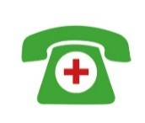
IMPORTANT! If skin is crusty, weepy or blisters, speak to a healthcare professional at your surgery the same day




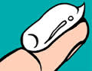
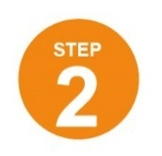




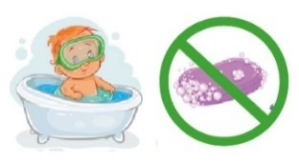
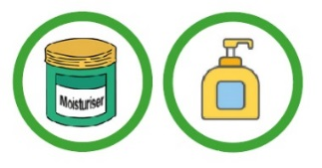
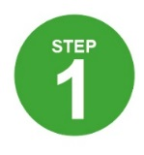

Use all over and often (usually twice daily)

Flare/control cream/ointment for my face:
______________________
Once/twice daily for _____ days

My non-soap product (for washing):
______________________

My moisturiser:
_______________

Bathe for a maximum of 10 mins
How to apply your moisturiser: www.bris.ac.uk/ewap/videos
No better within 7-14 days
Clear skin for 48 hours
Red/itchy skin
=
If skin is red or itchy, continue to use my moisturiser plus a flare control cream/ointment applied to the affected areas only
One fingertip treats an area the size of 2 adult hands
Apply at least 15 mins before or after moisturiser using the fingertip unit method www.bris.ac.uk/ewap/videos
Flare/control cream/ointment for my body: ______________________
Once/twice daily for _____ days

If skin is still not getting better speak to a healthcare professional at my surgery

Moisturise all over EVERY DAY even when my skin is not red/itchy
Avoid soap and bubble bath

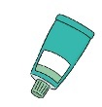
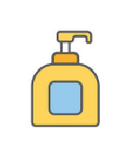


• Corticosteroids come in different strengths: mild (e.g. hydrocortisone 1%), moderate (e.g. eumovate) and potent (e.g. betnovate/elocon).
• Calcinuerin inhibitors (e.g. protopic) are also sometimes recommended.
• Stronger creams and ointments are safe to use if applied in the right way. Follow your plan for which treatment to use where and for how long.

Recognise a flare: A ‘flare’ is a worsening of the eczema. Skin may become red, sore, (more) itchy,
crack or bleed.
Recognise infected eczema: If skin suddenly worsens, weeps or crusts it could be infected and
your child may need antibiotics – seek urgent advice. Blisters or cold sores need antiviral treatment
– see a doctor the same day.
Food allergy: While it is more common for children with eczema to have a food allergy, it is not
usually the cause of eczema.

Flare control creams or ointments such as corticosteroids or calcineurin inhibitors treat red, itchy skin
• Moisturisers can also be used to wash with
but take care, they can make the bath/shower
slippy
• PAT your skin dry after bathing and apply your moisturiser straight afterwards.
• Applying moisturisers can be messy, but they wash off.
• FIRE HAZARD – Keep greasy ointments away from flames.
- • It’s ok to try different moisturisers, talk to your
GP/nurse if you don’t like one you have been
given.
• Expect to use large amounts – up to a large pump/tub (500ml/g) a week.
• If your moisturiser comes in a tub, use a spoon to scoop the moisturiser out. Getting it out with your hands can contaminate the pot and lead to skin infections.
Moisturising the skin keeps moisture in and protects against outside irritants. Find a moisturiser that suits you and your child and use it every day
Try to break the “itch-scratch”
cycle by tapping or blowing on the itch area; using a cold pack; or wearing cotton gloves at night.
There are different types of
moisturisers - if you don’t like yours, ask your GP for
a different one.
Things that can make the skin worse
• Soaps and bubble baths
• Perfumed products
• Detergents
• Wool clothing
• Extremes of temperature (e.g. hot bath water)
• Sand, soil, modelling clay, paints
• Stress
Links to check out

http://eczema.org/
http://www.nottinghameczema.org.uk/
http://www.nhs.uk/conditions/Eczema-(atopic)
http://eczemaoutreachscotland.org.uk/
Top Tips
• Moisturise every day, even when the skin is clear
• Apply moisturiser using downward strokes – do not rub in
• Do an extra rinse when washing clothes
• Wear soft, comfortable, loose clothing
• Keep fingernails short to prevent damage to skin
• Remember to re-order your creams
Eczema is a long-term condition that comes in cycles – getting worse and better. Good skin care with two treatments (moisturiser and flare cream/ointment) used well can control most children’s eczema.
[Eczema essentials]

 | Record of your child’s  treatment preferences

My treatment | When used | Rate your treatment |  |  | Notes
e.g. Hydromol  ointment | January-March 2017 |  |  |  | Effective but greasy when put on skin

Other treatments tried (prescribed or non-prescribed):

 | © University of Bristol 2017 (Fingertip unit image reproduced with permission from Australasian Society of Clinical Immunology and Allergy (ASCIA) www.allergy.org.au)  WAP freely available for use by children, parents and clinicians. Please obtain permission before use in research or modifying. For full licence and further information see www.bristol.ac.uk/ewap

